Manage Authorization

Description
This project involved auditing and modifying file and directory permissions in the /home/researcher2/projects directory to align with security and access control policies. Tasks included identifying files with incorrect permissions, adjusting read/write/execute access for users, groups, and others, and securing sensitive files and directories from unauthorized access.

Initial Permissions Layout

Name | Type | Owner | Group | Permissions
drafts | Directory | researcher2 | research_team | drwx--x---
project_k.txt | File | researcher2 | research_team | -rw-rw-rw-
project_m.txt | File | researcher2 | research_team | -rw-r-----
project_r.txt | File | researcher2 | research_team | -rw-rw-r--
project_t.txt | File | researcher2 | research_team | -rw-rw-r--
.project_x.txt | Hidden | researcher2 | research_team | -rw-rw-r--

Tasks
Task 1: Check file and directory details
- Navigate to the projects directory
- List contents with permissions
- Identify:
  - Group owner is research_team.
  - Permissions show that project_k.txt has rw-rw-rw- (others have write access).
- Check hidden files.
- Confirm .project_x.txt exists.
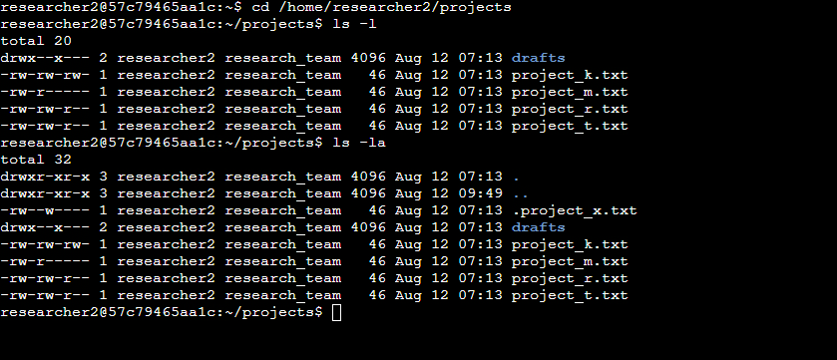
Task 2: Change file permissions
- Remove write permissions for others from project_k.txt.
- Remove read permissions for the group from project_m.txt.
- Verify changes.
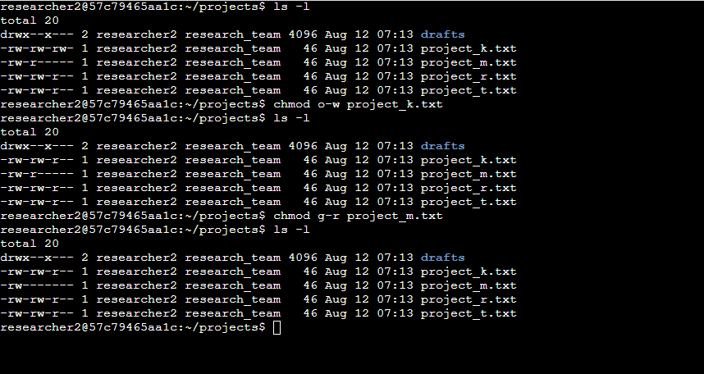

Task 3: Change file permissions on a hidden file
- Check permissions of .project_x.txt
  - You’ll see both user and group have write permissions.
- Remove write permissions for both user and group, ensuring they can only read.
- Verify changes
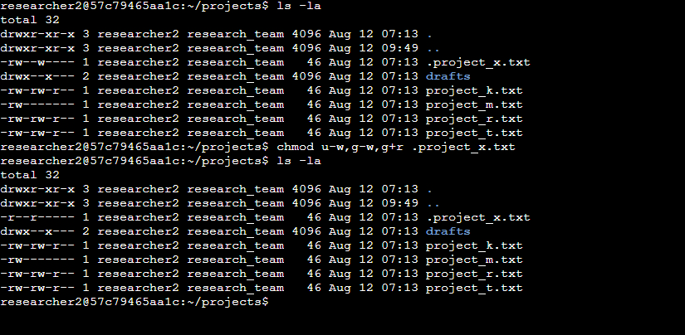
Task 4: Change directory permissions
- Check drafts directory permissions
  - Confirm group has execute permission.
- Remove execute permissions for the group.
- Verify changes.
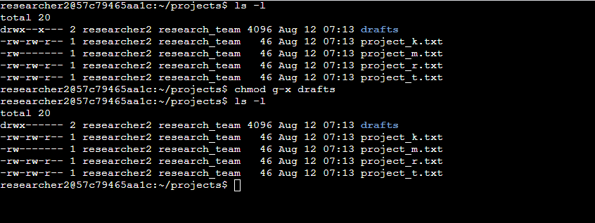

Tasks Completed
- Check file and directory details – Navigated to /home/researcher2/projects, listed all files including hidden ones using ls -l and ls -la, and identified the research_team as the owning group. Detected .project_x.txt as a hidden file.
- Change file permissions – Removed write permissions for others on project_k.txt and revoked read permissions for the group on project_m.txt to ensure only the user had access.
- Change hidden file permissions – Updated .project_x.txt so that both user and group retained read-only access, preventing accidental or unauthorized modifications.
- Change directory permissions – Removed execute permissions for the group on the drafts directory, ensuring only the researcher2 user could access its contents.

Final Permissions Layout

Name | Type | Owner | Group | Permissions
drafts | Directory | researcher2 | research_team | drwx------
project_k.txt | File | researcher2 | research_team | -rw-rw-r--
project_m.txt | File | researcher2 | research_team | -rw-------
project_r.txt | File | researcher2 | research_team | -rw-rw-r--
project_t.txt | File | researcher2 | research_team | -rw-rw-r--
.project_x.txt | Hidden | researcher2 | research_team | -r--r--r--

Skills Demonstrated
- Linux permission management (chmod, ls -l, ls -la)
- Understanding and interpreting file permission strings
- Securing sensitive files and directories from unauthorized access
- Managing hidden file permissions in Linux

Glossary
ls -l
- ls – Lists directory contents.
- -l – Displays a detailed (long) listing, including permissions, owners, sizes, and dates.
ls -la
- -a – Includes hidden files (those starting with a dot).
chmod o-w project_k.txt
- chmod—Changes file permissions.
- o-w – Removes write permission from "others."
- project_k.txt—The file to modify.
chmod g-r project_m.txt
- g-r—Removes read permission from the group.
- project_m.txt – The file to modify.
chmod u-w,g-w,g+r .project_x.txt
- u-w – Removes write permission from the user.
- g-w – Removes write permission from the group.
- g+r—Grants read permission to the group.
- .project_x.txt – The hidden file to modify.
chmod g-x drafts
- g-x – Removes execute permission from the group.
- drafts—The directory to modify.

